**NEURAL NETWORKS DEEP LEARNING**

Lavanya Sushma Gorijala

700760704

Github link: <https://github.com/lavanyasushma/ICP2>

Video link:

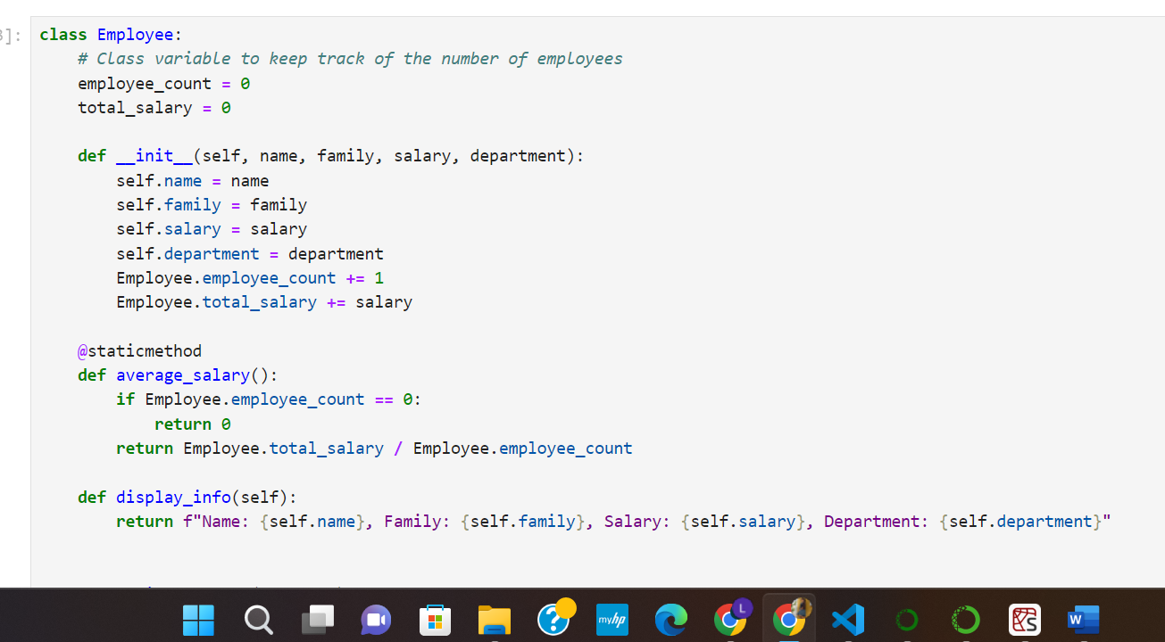

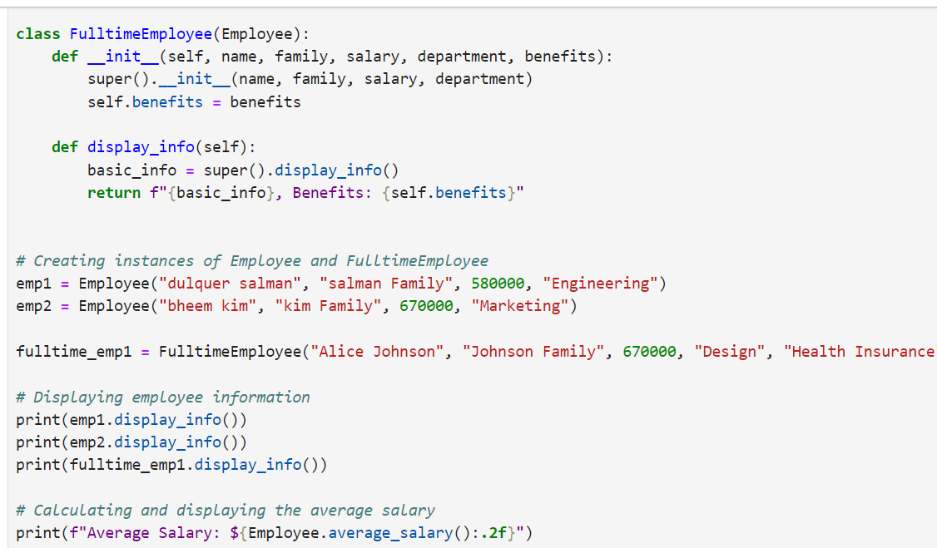

Output:

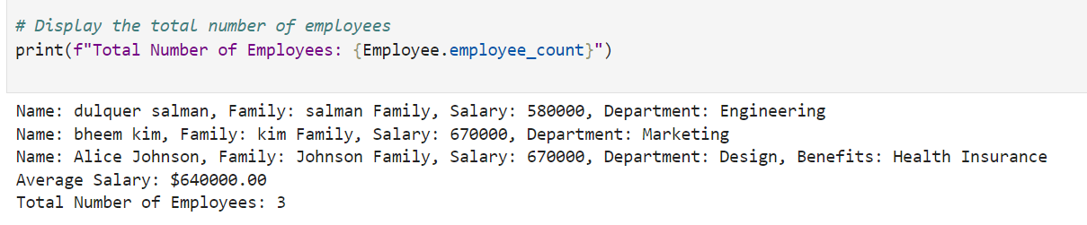

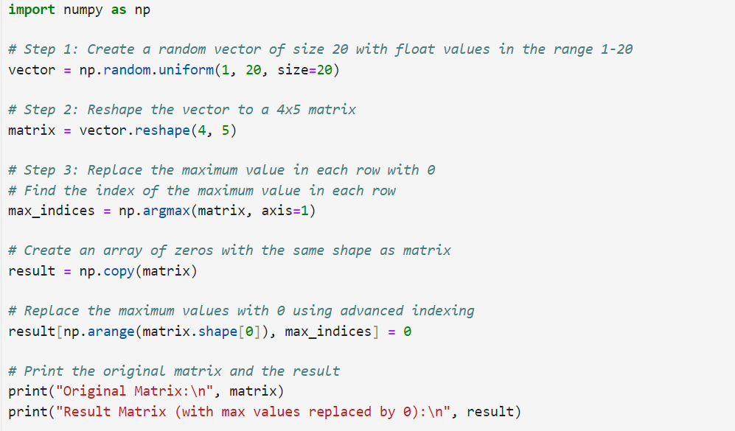

**Output:**

